**X-CALI**

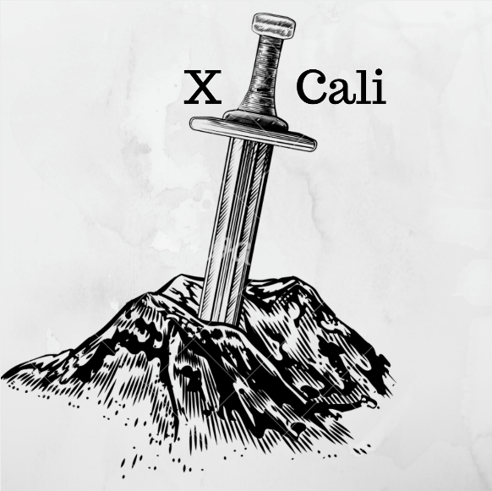

**Critical Design Review Report**

*“Design of Robots Collaboratively Carrying a Long Object Through an Open-Top Maze”*

Submitted to: Ali Özgür Yılmaz

Date of Submission: March 9, 2018

**Company Shareholders**

* Oytun Akpulat 2093201 [oytun.akpulat@metu.edu.tr](mailto:oytun.akpulat@metu.edu.tr)
* Göksenin Hande Bayazıt 2093441 [hande.bayazit@metu.edu.tr](mailto:hande.bayazit@metu.edu.tr)
* Emre Doğan 2093656 [dogan.emre@metu.edu.tr](mailto:dogan.emre@metu.edu.tr)
* Taha Doğan 2093672 [taha.dogan@metu.edu.tr](mailto:taha.dogan@metu.edu.tr)
* Burak Sezgin 2094456 [burak.sezgin@metu.edu.tr](mailto:burak.sezgin@metu.edu.tr)

Contents

Introduction 3

Design Description 3

System Description 3

Subsystem Analysis 3

Body: plank, şase boyutları, pil 3

Detection: kameralar, sensörler, algoritma 3

Movement: tekerler motorlar, algoritma 3

Component Analysis 3

Microcontrollers: RP3, Arduino Uno 3

Sensors: Ultrasonic, IR 3

Motors: 3

Chassis: wooden 3

Wheels: material, plastic mad wheel: aluminum 3

Requirement Analysis 3

Risk Analysis 3

Power Consumption Analysis 3

Cost Analysis 3

Development Schedule 3

Modification to Conceptual Design 3

Test Procedures and Test Results 3

Organization Plan 3

Conclusion 3

References 3

# Introduction

This report describes the hardware and software progress and implementations carried out so far.

As the company X-Cali, we have completed most of the hardware implementation of the project. Physical architecture of the robot has been designed and almost finalized. We have also remarkably proceeded at the software part of the project. For subsystems, the design procedure was completed and final decisions were made. Even though we do not have a full functioning robot now, we made tests on subsystems and the results of these tests are included in this report.

Detailed description of the overall system and subsystems are given in this report. Technical details of designed systems were explained. Moreover, block diagrams, flow charts and 3D technical drawings of the subsystems are included. At the “Modifications to Conceptual Design” part, all the development and modifications to the system were clearly clarified. The cost and risk analyses of the robot are made. Finally, we mentioned our future plans in “Development Schedule”.

# Project Goals and Objectives

## Problem Definition

In this project, we aim design and produce a robot that can carry a long object, plank, through a maze collaboratively with another robot. Maze specifications is as follows.

* There are 5 streets maximum on the one side of the maze
* Street are 250 mm wide
* Maze walls are with 100 mm height
* Maze walls’ width is 10mm
* 10 mm from the top of the maze walls are painted with black, the rest is white.

After robots are connected each other with the plank, one of them will be chosen as master and the other slave. Master leads the way in the maze and slave robot follows master. The main problem in this project is “Handling the corners”. That is, in the case of U-turn, robots are not able to handle it at once. The whole procedure in such a case is given in the Figure XXXXXXXXXXXX.

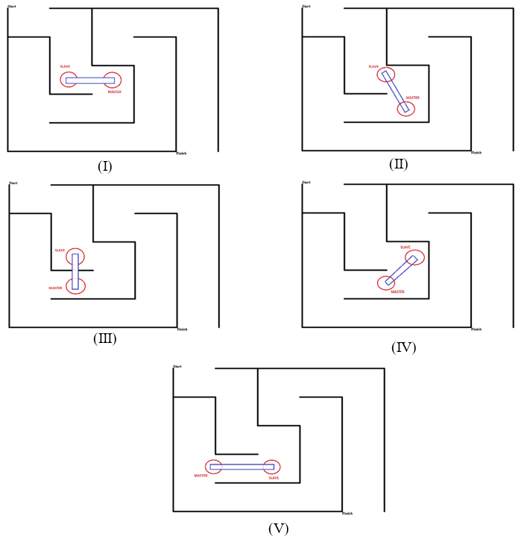

Figure XXXXXXXXXXXXXXXXXX: U-turn demonstration

Robots are not allowed to communicate each other directly. Thus, during the maze solving operation, our robot X-Cali performs *sensing*. Both active and passive sensing approaches are applied on X-Cali.

As X-Cali Group, our main aim is to design and produce a robot, is a solution for this maze problem, in in an efficient way. Efficiency is in terms of both software and hardware efficiency. Robustness is achieved firstly in the mechanical design period and it is improved with software. Additionally, we have taken to account aesthetic beauty as we bear commercial concerns. The robot is designed symmetrical manner so that its posture increases its sales appeal. Because of the commercial concerns, after sale services are also provided for this design.

## Objectives

### Company Objectives

* Improving theoretical and practical experiences
* Applying theory on practice
* Continuing in grow and being a corporate
* Overcoming the project
* Increasing the team skills: productivity and efficiency and time management
* Placing first in the contest at the very end of semester

### Project Objectives

* Minimalist and efficient design
* Considerably low power consumption
* Completing the maze without collision and damaging the other robot
* Keeping customer satisfaction high by providing high quality after sales services

# Design Description

## System Description

## Subsystem Analysis

### Body: plank, şase boyutları, pil

### Detection

In the robot, there are mainly 3 subsystems to have a knowledge of the surrounding of the robot. This subsystem supplies the most important data for the decision unit. All decisions will be made with respect to the signals taken from

* Camera
* IR Sensors
* Ultrasound Sensors.

These awareness sensors help the robot find its path in the maze and lead or follow the other robot. The structure of this module is given in Figure XX.

Figure XX. Block Diagram of the Surrounding Awareness Submodule

**Angle Detection**

In the plank angle detection, the image capture is taken from the camera and processed simultaneously. The main purpose is to achieve the angle of the plank to be able to identify the other robot’s moves. With interpreting this angle in the critical points of the maze, the robot will be able to find its correct move in the decision unit.

For this, we firstly developed an algorithm to be able to detect the correct angle. As the camera within the robot will see the plank in an uneven pattern, this image needs to be fixed so that we could find the angle in a more reliable way. The procedure is given below,

1. The colorful image is taken as an input
2. The input image is masked as processing in the grayscale is much more practical.
3. The uneven masked is image is applied some transforms to get a more linear shape.
4. Angle finding algorithm is applied to the transformed image.

An example of this process can be observed in Figure XX.



1. (b)



(c) (d)

*Figure XX. The original input image (a), the masked version of the input image (b), the transformed version the input image, not uneven (c), angle detecting algorithm applied to the transformed image (d).*

After the angle of the plank is detected, this information is sent to the decision unit so that the decision unit sends the necessary signals to the motor driver.

An illustration of this process can be seen in the command prompt in Figure XX.



Figure XX. Angle Detection Output of the Plank.

All this algorithm process was debugged and developed on the computers. Then, we made a demonstration on the real robot, to see whether it could find the angle of the plank in a correct manner. Figure XX given below is a basic demonstration of the algorithm on the Raspberry Pi 3, while all the robot components are integrated.



1. (b)

Figure XX. Demonstration of the Angle Detection Algorithm on the Robot.

The camera captures the plank from the top view(a), then the angle detection algorithm is applied to find the angle(b).

**Maze Mapping**

Besides the angle detection of the plank, we also use the camera to map the maze from the top view. Maze mapping is important because it eases to decide what the robot should do as its next move. For this mission, the camera used in the angle detection cannot be used as the perspectives are quite different. So, we will use another webcam camera to map the maze located higher than the angle detecting camera.

Especially in the U and L turns, mapping the maze is important because the robot will remember its last moves and complete the turn with respect to this fact.

In our first try, we tried to map the maze visually such that while the robot is moving, the camera at the top will be observing the maze and from the edges of walls, it will create a map of the maze. A visual illustration of this mapping is given in Figure XX.



Figure XX. Maze Mapping Algorithm Visualization.

After mapping the path, this information is used to save a few movements which the robot completed. This becomes an important issue especially when there is a L or U turn. In the Figure XX, it is also available to observe these movement detections made.

This method is useful but it has some disadvantages. Mainly, this process is comutationally complex and it reduces the performance of other processes done in Raspberry Pi 3. So in stead of this, we thought about a new method of mapping which is less complex in computation.

In this method, a sufficient sized of matrix is created. As the robot goes through a path, this matrix is filled with “1”s to represent the path in the matrix. This method may seem strange but as it consumes much less CPU, it is preferrable rather than the visualization method mentioned above. An example of mapping array can be seen in Figure XX.

$$path_matrix=\begin{matrix}0 & 0 & 0 & 0 & 0 \\ 0 & 0 & 1 & 1 & 1 \\ 1 & 1 & 1 & 0 & 0 \\ 0 & 0 & 0 & 0 & 0 \\ 0 & 0 & 0 & 0 & 0\end{matrix}$$

Figure XX. An Example of Mapping Matrix.

Path matrix is a 5x5 matrix initialized with all 0s. The robot begins its path from $path_matrix[3,1]$ point. Then it follows the $path_matrix[3,2]$, $path_matrix[3,3]$, $path_matrix[2,3]$, $path_matrix[2,4]$, $path_matrix[2,5]$. This visualization type is not strong but lets us to save the last few moves the robot made.

**Finding the Path Through the Maze**

Besides the plank’s angle detection and maze mapping, the robot should be aware of its surrounding while moving. For this subsystem, we have 2 options,

* Infrared (IR) Sensor
* Ultrasonic Sensor

IR and ultrasound sensors give information about the obstacles around the robot. This is quite important for the robot to be able to drive itself through the maze platform without hitting walls.

Both of them have their advantages explicitly.

*Advantages of Ultrasonic Sensors Over IR Sensors*

* They are completely insensitive to environmental factors like,
  + - * + Light
        + Dust
        + Vapor
        + Mist.

So, this sensor type makes the system more independent to the environmental factors which is good.

### Movement: tekerler motorlar, algoritma

## Component Analysis

### Microcontrollers: RP3, Arduino Uno

### Sensors: Ultrasonic, IR

### Motors:

### Chassis: wooden

### Wheels: material, plastic mad wheel: aluminum

## Requirement Analysis

## Risk Analysis

### Mechanical Risks

* The chassis of the robot is wooden. Wooden materials may lose their stiffness as time passes. Thus, it can be fragile over time.
* If robot is treated harshly, the camera holder and plank holder may be broken from the chassis.

### Safety Risks

* Li-Po Batteries in the robot may explode or start a fire or release poisonous gases during usage of the robot.
* Li-Po batteries may explode or start a fire or release poisonous gases during charging them.
* Overheating of microcontrollers may cause burns on the skin.

### Customer Risks

* Two more companies are preparing to enter this business with the same aspects and goals. This may cause decrease in the customer or failure in the sales target.

## Power Consumption Analysis

## Cost Analysis

After a detailed research process, we checked the market in order to be able to figure out how to solve the problem with the minimized cost. By making a comparison list, we found our optimal component set and purchased them. This component list can be observed below in Table XXXXXXXXXXXXXXX.

**Table XXXXXXXXXXXXXXX: Cost Analysis of the Project**

|  |  |  |  |
| --- | --- | --- | --- |
| **Product Name** | **Price / Product** | **Quantity** | **Total Price** |
| Raspberry Pi 3 | ₺181.65 | 1 | ₺181.65 |
| HC-SR04 Arduino Ultrasonic Distance Sensor | ₺5.50 | 4 | ₺22.00 |
| E18 D80NK Infrared Sensor | ₺22.75 | 2 | ₺45.50 |
| Webcam | ₺31.00 | 2 | ₺62.00 |
| Motors | ₺45.00 | 2 | ₺90.00 |
| L298N Motor Driver | ₺12.00 | 1 | ₺12.00 |
| Mad wheel | ₺5.00 | 1 | ₺5.00 |
| Robot Chassis | ₺10.00 | 1 | ₺10.00 |
| Jumper Cables | ₺10.00 (/set) | 1 | ₺10.00 |
| 11.1V 1300mA LIPO Battery | ₺69.50 | 1 | ₺69.50 |
| LIPO Battery Charger | ₺45.00 | 1 | ₺45.00 |
| 24V-5V 3A DC to DC USB Power Module | ₺6.65 | 1 | ₺6.65 |
| Arduino UNO | ₺40.00 | 1 | ₺40.00 |
| Screw set | ₺30.00 | 1 | ₺30.00 |
| Plank and ball bearings | ₺20.00 | 1 | ₺20.00 |
|  |  | **TOTAL PRICE** | ₺649.30 |

Please note that, we were allowed to spend up to $200,-. Total price is, according to today’s currency, $171.05. That is, we are far below the top limit.

## Development Schedule

# Modification to Conceptual Design

In the Conceptual Design Report, different solution approaches and details of both software and hardware parts of the project were explained. After the report was submitted, we made some tests and evaluated advantages and disadvantages of the choices we made in hardware components. According to the results of this evaluation, we decided to modify some parts of the hardware of the project. These modifications are as follows:

* Arduino will be used for motor control since we already have a motor control code that works properly in Arduino.
* We added Infrared Sensor to the robot just in case Ultrasonic Sensors does not work properly.
* We decided to add an extra camera which means robot will have two cameras instead of a single camera. The reason for this is that both the movement of the plank and top of the maze could not be observed with a single camera.
* The motors we used in the demo in first semester was not powerful enough. Hence, we have bought new motors that are powerful enough and have encoders. Encoders was needed for obtaining direction information. The data which is coming from encoder will be processed in Arduino.



Figure : New motor with encoder

# Test Procedures and Test Results

# Deliverables

The first robot of X-Cali is designed for general usage. There is no specific client profile for our product. The robot can be used for different purposes such as gaming or educational purposes.

The expected deliverables of the work packages of our project can be seen in Table.

|  |  |  |
| --- | --- | --- |
| **The Work Package** | **Corresponding Deliverable** | **Status** |
| Research | Tentative Report | Completed |
| Component Tests | Results and analysis of the component test | Completed for the ultrasonic sensors and RP3. Test plan is achieved. |
| Communications Subsystem  Design | Results of the procedure of receiving& processing data | Not completed. |
| Mechanical Subsystem Design | Driving tests and analysis of the robot | Completed. Test plan is achieved. |
| Software Subsystem Design | Documentation of the algorithms and debugging results | Started but not completed. |
| Overall System Implementation & Tests | A robot completing the labyrinth by itself | Not completed yet. |
| Demonstration | A robot completing the labyrinth collaboratively with the other groups. The product within its package. | Not completed. |

Table : Expected Deliverables of the Work Packages of the Project

The package of our product will include the main body of the robot, a plank, user manual, 2 spare tires, a backup battery and a remote controller deciding the robot to become master or slave.

The size of the robot can be adjusted according to the customers demands. The product will be prepared in 10 weekdays after the order. Users can find all the necessary information about the product in the user manual.

You can contact us via our web site http://www.xcali.ml.

# Organization Plan

Figure XXXXXXXXX: Organizational Structure of X-Cali

# Conclusion

The engineers of the company X-Cali have prepared this report in order to inform customers about the progress of the project implementation. The present situation of the project was explained elaborately. The detailed solutions we have come up with were included.

All the subsystems, modifications to the conceptual design, the risk analysis and safety issues were included. Necessary tests were made for the subsystems. The test procedures were explained and the test results were interpreted in this report. Detailed explanations of the overall system and subsystems were given. Team members went shopping last week and bought necessary components, hence the cost table was updated. Gantt Chart was also updated.

At this point, we can say that our robot is almost ready. Our design and implementation is almost finished, only slight improvements will be done. We are working to succeed and finish this project as soon as possible.

# References